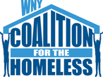
Homeless Outreach Incident Report

Referral Agency: _________________________________

Complainant Agency: ________________________________

Client’s name: _______________________ Date of birth: ____/____/______
Date of incident: ____/____/______

Incident summary:

Please record any incidents including denials for shelter placements, lack of hospital discharges, DSS denials, etc to help us best understand what our clients may need and how to advocate for them. Please bring these to the monthly outreach meeting where they will be collected.

