WNY Coalition for the Homeless  PO Box 618  Buffalo, NY 14205 | 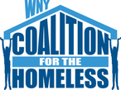

To:

 | Please make checks payable to: WNY Coalition for the homeless
DESCRIPTION |  | TOTAL
Annual Agency Membership: 4/1/2016-3/31/2017 |  | 50.00
Additional donation
Total
Make all checks payable to WNY Coalition for the Homeless.

If you have any questions concerning this invoice, contact Kelly Dodd, kdodd@211wny.org or 716-842-2608.
Thank you for your Membership & support!

